Simple University Application

Project Set up and Usage Document

Josemari Acielo

Contents

Introduction 3

Technology 3

API (Back End) 3

APP (Front End) 3

Set up 3

Source Code 3

API 3

APP 4

Install Node.Js 4

Change the URL in the project 4

Via Visual Studio developer terminal 5

Via Powershell 5

Usage 5

Students Page 5

Create Student 6

Edit Student 6

Delete Student 6

Limitation on Student Deletion 6

Course Page 6

Create Course 6

Edit Course 7

Delete Course 7

Limitation on Course Deletion 7

Applications Page 7

Create Application 7

Edit Application 8

Delete Application 8

# Introduction

This is a simple application that can create students, courses, and applications for the simple university.

# Technology

## API (Back End)

The API is developed using the following stack:

1. .NET CORE 8 Web API
2. Entity Framework using in Memory to store database
3. FluentValidation for input validation
4. NUnit for the unit testing modules
5. Shouldy for the unit testing modules

## APP (Front End)

The web site is developed using the following stack

1. Vue.js
2. Quasar Framework

# Set up

Usually the api and front end will be deployed to a server of your choice. However without a proper host, cross origin communication might be a challenge. To set up this example, we can utilize the dev environment out of the box of Visual Studio for the API and node.js for the front end.

## Source Code

Clone the source code from github: <https://github.com/jmacielo23/SUAS.git>

## API

Initialize the API first, open the solution under SUAS_API (found in the source code) and perform the following:

1. Build the solution
2. Run the solution (ctrl+F5) in debug mode (we want to see the swagger ui)
3. The web api should open the swagger ui with the exposed methods for Applications, Courses, Students  
   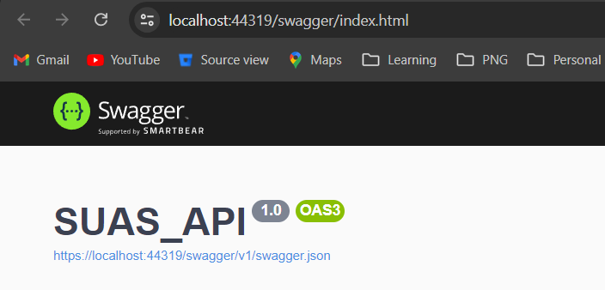
4. Take note of the URL, in the illustration above, its ‘https://localhost:44319’

## APP

Once the API is running, we can run the front end. You can either use the developer terminal in Visual Studio or run it in powershell. Choose any method and follow the instructions below

### Install Node.Js

Before running the application, you have to install node.js in the machine. Follow the instructions on how to install node.js in your machine from the node.js [official website](https://nodejs.org/en/download/package-manager)

### Change the URL in the project

Change the url value on the following pages, get the value from the running dev instance of the api, in the example above its [**https://localhost:44319**](https://localhost:44319)

#### StudentsPage.vue

Open StudentsPage.vue, find and change the URL [**https://localhost:44319**](https://localhost:44319) to the running URL of the API in your machine

#### CoursesPage.vue

Open CoursesPage.vue, find and change the URL [**https://localhost:44319**](https://localhost:44319) to the running URL of the API in your machine

#### ApplicationsPage.vue

Open ApplicationsPage.vue, find and change the URL [**https://localhost:44319**](https://localhost:44319) to the running URL of the API in your machine

### Via Visual Studio developer terminal

1. Open Visual Studio and open the folder name SUAS_APP
2. Open the developer terminal and type and run the command **quasar dev**
3. The developer terminal will show the port being used and your default browser will open the application

### Via Powershell

1. Run powershell as administrator
2. Change the directory under the folder SUAS_APP found in the source code
3. Type and run the command **quasar dev**
4. The powershell will initialize the components and the application will load on your default browser

The main page should look like this

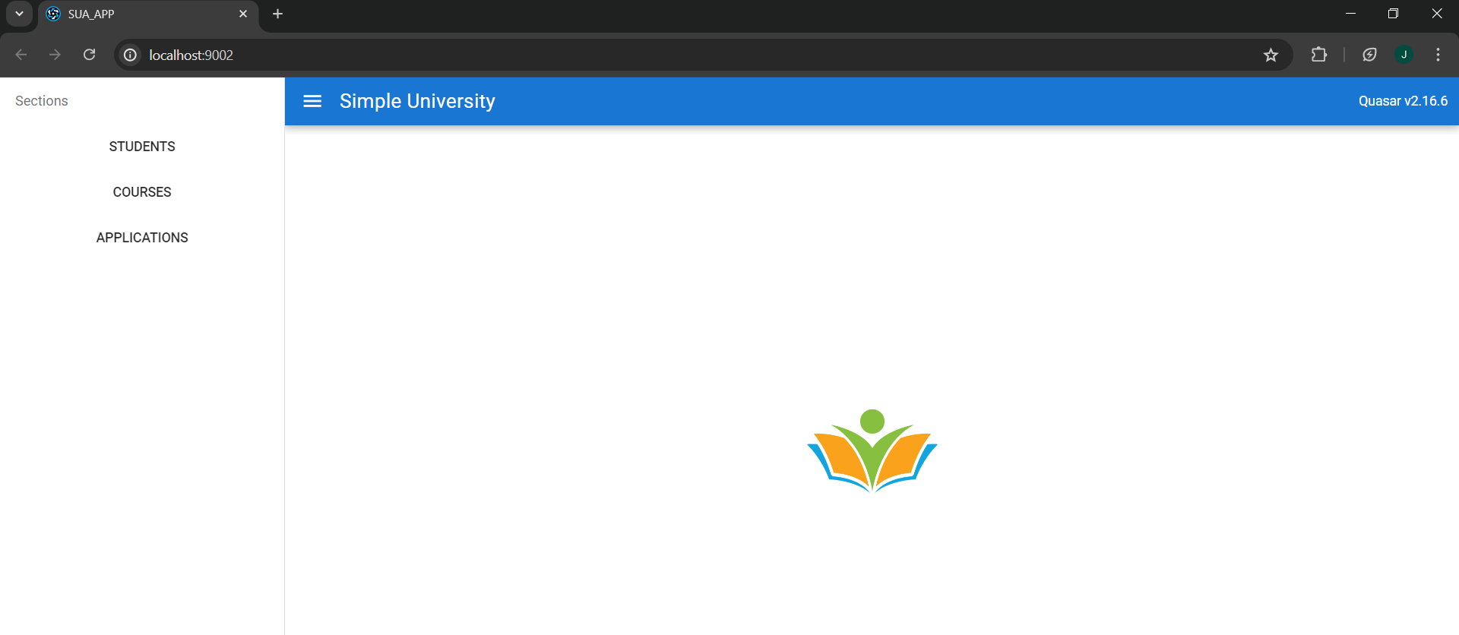

# Usage

This section briefly explains how to navigate and use the application

## Students Page

To navigate to the Students page, expand the menu bar and click the **STUDENTS** tab

### Create Student

To create a student, fill in the text box found in the student page. The following data type should be followed:

|  |  |  |  |  |
| --- | --- | --- | --- | --- |
| Item number | Field Name | Data Type | Data Length | Required |
| 1 | ID | Int |  | Yes |
| 2 | First Name | String | 2 (min), 30 (max) | Yes |
| 3 | Last Name | String | 2 (min), 30 (max) | Yes |
| 4 | Date of Birth | DateTime | Valid format: YYYY-MM-DD | Yes |
| 5 | Email | String | Email format | No |
| 6 | Phone Number | String | Valid international format (+63 xxx xxx xxxx) | No |

Click the **Create Student** button, the record will be saved and will reflect on the Students Table

### Edit Student

To edit a student record, click on the **Edit** button on the row of the student record that you wish to Edit

A pop up window will appear containing the information of the student, modify the required fields and click **Save Changes** buttonto apply the changes. The updated record will automatically reflect in the students table

### Delete Student

To delete a student record, click the **Delete** button on the row of the student record you want to delete. Once successful, the table will automatically update.

### Limitation on Student Deletion

If a student has an active application, you won’t be able to delete the student record. You have to delete all the applications for the student in order to proceed with the deletion.

## Course Page

To navigate to the Courses page, expand the menu bar and click the **COURSES** tab

### Create Course

To create a course, fill in the text box found in the courses page. The following data type should be followed:

|  |  |  |  |  |
| --- | --- | --- | --- | --- |
| Item number | Field Name | Data Type | Data Length | Required |
| 1 | ID | Int |  | Yes |
| 2 | Code | String | 5 (min), 10 (max) | Yes |
| 3 | Title | String | 5 (min), 50 (max) | Yes |
| 4 | Credits | Int |  | Yes |

Click the **Create Course** button, the record will be saved and will reflect on the Courses Table

### Edit Course

To edit a course record, click on the **Edit** button on the row of the course record that you wish to Edit

A pop up window will appear containing the information of the course, modify the required fields and click **Save Changes** buttonto apply the changes. The updated record will automatically reflect in the courses table

### Delete Course

To delete a course record, click the **Delete** button on the row of the course record you want to delete. Once successful, the table will automatically update.

### Limitation on Course Deletion

If a course is within an active application, you won’t be able to delete the course record. You have to delete all the applications that use the course in order to proceed with the deletion.

## Applications Page

To navigate to the Applications page, expand the menu bar and click the **APPLIATIONS** tab

### Create Application

To create a course, fill in the text box found in the courses page. The following data type should be followed:

|  |  |  |  |  |
| --- | --- | --- | --- | --- |
| Item number | Field Name | Data Type | Data Length | Required |
| 1 | ID | Int |  | Yes |
| 2 | Student ID | Int |  | Yes |
| 3 | Course ID | Int |  | Yes |
| 4 | Application Date | DateTime |  | Yes |

The Student ID is the ID of the student you want to associate with the application.

The Course ID is the ID of the course you want to associate with the application.

Click the **Create Application** button, the record will be saved and will reflect on the Applications Table

### Edit Application

To edit an application record, click on the **Edit** button on the row of the application record that you wish to Edit

A pop up window will appear containing the information of the appliation, modify the required fields and click **Save Changes** buttonto apply the changes. The updated record will automatically reflect in the applications table

### Delete Application

To delete an application record, click the **Delete** button on the row of the appliation record you want to delete. Once successful, the table will automatically update.